Lost And Found system
A
Project Report Submitted to



Mandsaur University, Mandsaur
Towards Partial Fullfillment for the Award of

Bachelor of Computer Application

Submitted By
Jitesh porwal
Enrollment No. 21CSA3BCC1009

Department of Computer Science & Application
Mandsaur University, Mandsaur
2023-24
Lost And Found system
A Project Report Submitted to

Mandsaur University, Mandsaur
Towards Partial Fulfillment for the Award of

Bachelor of Computer Application

Submitted To Submitted By Prof. Rahul Panola Jitesh porwal
Enrollment No.
21CSA3BCC1009

Department of Computer Science & Application
Mandsaur University, Mandsaur
2023-24

Department of Computer Science & Application
Mandsaur University, Mandsaur

CERTIFICATE

The Project Report entitled “Lost And Found system” being submitted by Jitesh porwal (Enrollment No.:21CSA3BCC1009) has been examined by us and is hereby approved for the award of degree Bachelor of Computer Application for which it has been submitted. It is understood that by this approval the undersigned do not necessarily endorse or approve any statement made, opinion expressed or conclusion drawn therein, but approve the dissertation only for the purpose for which it has been submitted.

Internal Examiner External Examiner
Date: Date:

Department of Computer Science & Application
Mandsaur University, Mandsaur

PROJECT REPORT APPROVAL SHEET

The project report work entitled “Lost And Found system” submitted by Jitesh porwal (Enrollment No.:21CSA3BCC1009) is approved as partial fullfillment for the award of the Bachelor of Computer Application degree by Mandsaur University, Mandsaur (M.P).

Approved by

Prof. Nilesh Jain
(HOD CA)

Department of Computer Science & Application
Mandsaur University, Mandsaur

DECLARATIONS

I hereby declare that the work, which is being presented in the project report, entitled “Lost and found system” partial fulfillment of the requirements for the award of degree of Bachelor of Computer Application submitted in the Department of Computer Application (Mandsaur University, Mandsaur) is an authentic record of my own work carried under the guidance of Prof. Rahul Panola I have not submitted the matter embodied in this report for award of any other degree.

Jitesh Porwal
Enrollment No:
21CSA3BCC1009

ACKNOWLEDGEMENT

I take the opportunity to express my cordial gratitude to Prof. Nilesh Jain, HOD Department of Computer Science & Application, Mandsaur University, Mandsaur (M.P.) for the valuable guidance and inspiration throughout the dissertation work. I feel thankful for his innovative ideas, which led to successful completion of this work.
I give special thanks to Prof. Rahul Panola, Assoc. Prof., Department of Computer Science & Application, Mandsaur University, Mandsaur (M.P.) to always being willing to help find solutions to any problems I had with my work.

I express my gratitude and thanks to all the staff members of Department of Computer Science & Application for their sincere cooperation in furnishing relevant information to complete this project report well in time successfully.
Lastly but not least I must express my cordial thank to my parent, family members and friends who gave me the moral support without which it was impossible to complete my project work. With this note I thank everyone for the support.

Jitesh prowal

ABSTRACT

The "Lost and Found System" is a comprehensive solution designed to address the challenges associated with tracking and recovering lost items in a user-friendly and efficient manner. In a world where misplaced belongings often lead to frustration, this project endeavors to streamline the reporting and searching process, fostering a sense of community engagement.
The project encompasses meticulous planning, design, and testing phases to ensure the system's reliability, security, and overall effectiveness. The implementation of robust testing methodologies, including unit testing, integration testing, and validation testing, guarantees the system's integrity and performance.
Acknowledging the inherent limitations of project development, such as scope creep and resource constraints, effective project management strategies have been employed. These include clear communication, adaptability, and proactive risk management to address challenges and ensure project success.
Looking towards the future, the system holds immense potential for expansion and improvement. Incorporating features such as mobile applications, geolocation integration, and machine learning for matching aims to elevate the system's capabilities. Collaboration with law enforcement, social media integration, and community involvement further enhance its impact on a broader scale.
In essence, the "Lost and Found System" serves as a foundational community-driven solution, providing a platform for users to report and search for lost items efficiently. Beyond its current functionality, the system is positioned for growth and adaptation to meet evolving user needs and technological advancements, making a meaningful contribution to simplifying the recovery of lost items and fostering community collaboration.

Keywords: Lost and Found System
- Item Tracking
- Community Engagement
- User-Friendly
- Efficiency
- Testing Methodologies
- Project Management
- Scope Management
- Resource Optimization
- Future Scope
- Mobile Application
- Geolocation Integration
- Machine Learning
- Community Collaboration
- Social Media Integration
- User Satisfaction
- Technology Advancements
- Security Measures
- System Reliability
- Evolutionary Development

Certificate |  | i
Dissertation Approval Sheet |  | ii
Declaration |  | iv
Acknowledgement |  | v
Abstract |  | vi
List of Figures |  | vii
List of Tables |  | viii

CHAPTER 1: INTRODUCTION 01 - 02
  - Aim of Project 01
  - Problem Definition 01
  - Problem Description 01
  - Need and Scope 02

CHAPTER 2: ANALYSIS 03
2.1 Software Process Model 03

CHAPTER 3: REQUIREMENT SPECIFICATION 04 - 05

  - Requirement Analysis 04
  - Software Specifications 04
  - Hardware Specifications 05
  - Non-Functional Requirements 05

CHAPTER 4: FEASIBILITY ANALYSIS 06

  - Technical Feasibility 06
  - Economic Feasibility 06
  - Behavioral Feasibility 06
  - Time Feasibility 06

CHAPTER 5: RISK ANALSIS 07- 08

  - Why Risk Management 07
  - Risk Projection 07
  - Types of Risks 07
    - Project Risk
    - Technical Risk
    - Business Risk
  - Known Risk 08
  - Predictable Risk 08
  - Unpredictable Risk 08

CHAPTER 6: TECHNOLOGY USED 09

6.1 Selection of Platform 09
6.2 Tool Selection 09
6.3 Database Used 09

CHAPTER 7: PLANNING AND DESIGNING 10 - 13

  - Planning 10
  - Designing 10
  - Entity Relationship Diagram 10
  - Data Flow Diagram 11
    - DFD Level 0
    - DFD Level 1
  - Use Case Diagram 11
    - Use Case For Admin 12
    - Use Case For User 12
  - Activity Diagram 12
  - Sequence Diagram 12
  - Class Diagram 13

CHAPTER 8: IMPLEMENTATION 14 – 33

CHAPTER 9: TESTING 34 - 36

  - Unit Testing 34
  - Integration Testing 34
  - Validation Testing 34
  - Test Case Design 35
  - Test Cases 36

CHAPTER 10: COST ESTIMATION AND 37 - 38
VERIFICATION CRITERIA

CHAPTER 11: LIMITATIONS OF PROJECT 39

CHAPTER 12: FUTURE SCOPE 40

CHAPTER 13: CONCLUSION 41

CHAPTER 14: BIBLIOGRAPHY/REFERENCES 42

LIST OF FIGURES
Figure No. | Title | Page No.
1.1 | ER Diagram | 22
1.2 | Data Flow Diagram | 23
1.3 | Data Flow Diagram | 22
1.4 | Home Page | 25
1.5 | Layout | 26

LIST OF TABLES
Table No. | Title | Page No.
3.1 | Data flow | 23

CHAPTER 1:
INTRODUCTION

1.1 Aim of Project
The aim of the "Lost and Found System" project is to develop a user-friendly and efficient web-based platform that allows users to report lost or found items. The primary objective is to create a centralized system where individuals can easily submit information about their lost possessions, and this data is then displayed on a website accessible to all users. The project aims to streamline the process of reporting and retrieving lost items, enhancing community collaboration and increasing the chances of reuniting people with their belongings.

1.2 Problem Definition
The "Lost and Found System" project addresses the inefficiencies of traditional methods by creating a centralized web platform. It solves problems such as delayed reporting, limited accessibility, and dispersed information. The aim is to provide real-time updates, bridge communication gaps, and increase visibility for lost and found items. The project strives to streamline the process, making it user-friendly and enhancing community collaboration.

1.3 Problem Description
The "Lost and Found System" project addresses issues such as inefficient reporting, limited accessibility, and dispersed information. Current methods lack real-time updates, making retrieval slow. Accessibility challenges and scattered information hinder the effective tracking of lost belongings. Communication gaps between those who lost items and finders pose coordination problems. Moreover, the localized visibility of information limits the chances of reuniting owners with their possessions. The project aims to resolve these challenges by creating a centralized, accessible, and user-friendly web platform for efficient lost item reporting and retrieval.

1.4 Need and Scope of lost and found system Minor Project
The "Lost and Found System" minor project addresses the need for a more efficient and accessible platform for reporting and retrieving lost items. By creating a centralized web system, the project aims to enhance the chances of reuniting individuals with their belongings in a timely manner. It focuses on improving communication between those who have lost items and those who have found them while extending the visibility of lost and found information beyond local communities. The scope of the minor project involves developing a user-friendly web platform to streamline the reporting process, consolidate information, and improve the overall effectiveness of the lost and found system.

CHAPTER 2:
ANALYSIS

2.1 Software Process Model:
The software process model selected for the "Lost and Found System" project is the Agile model. Agile is chosen for its iterative and incremental approach, promoting flexibility and adaptability throughout the development lifecycle. This model allows for continuous feedback, collaboration, and adjustments to better accommodate changing requirements. The Agile model is well-suited for dynamic projects like the "Lost and Found System," where user feedback and evolving needs play a significant role in shaping the final product. This approach ensures that the development team can respond promptly to emerging challenges, delivering a more responsive and user-centric

- Waterfall Model:
  - Description: The Waterfall model is a linear and sequential approach to software development. It consists of distinct phases such as requirements, design, implementation, testing, and maintenance.
  - Advantages: Simple and easy to understand, well-suited for small projects with clear and stable requirements.
  - Disadvantages: Less adaptable to changes, potential for lengthy development cycles, and limited customer involvement.
- Spiral Model:
  - Description: The Spiral model combines elements of both iterative and waterfall models. It involves a series of cycles, with each cycle representing a phase in the software development process.
  - Advantages: Flexibility to accommodate changes, risk management through regular iterations, and early identification of potential issues.
  - Disadvantages: Complexity increases with each iteration, and it may not be suitable for small projects.
- Agile Model:
  - Description: Agile is an iterative and incremental model that emphasizes flexibility, collaboration, and customer feedback. It involves short development cycles known as iterations or sprints.
  - Advantages: High adaptability to changing requirements, continuous customer involvement, and early and regular delivery of working software.
  - Disadvantages: Requires active customer participation, may be challenging for large teams or complex projects.
- Prototype Model:
  - Description: The Prototype model involves the creation of a prototype (an early, incomplete version of the system) to gather user feedback and refine requirements before the final system is developed.
  - Advantages: Effective for projects with evolving or unclear requirements, provides early user feedback, and reduces the risk of misunderstandings.
  - Disadvantages: May lead to incomplete or inaccurate prototypes, potential for increased development time and cost.
- V-Model:
  - Description: The V-Model is an extension of the waterfall model where each development stage corresponds to a testing phase. It emphasizes the relationship between development and testing activities.
  - Advantages: Clear and well-structured process, each development stage has a corresponding testing phase, and early defect detection.
  - Disadvantages: Limited flexibility to accommodate changes, potential for lengthy development cycles.

CHAPTER 3:
REQUIREMENT SPECIFICATION

3.1 Requirement Analysis:
3.1 Requirement Analysis
Requirement analysis is a critical phase in the software development process where the project team identifies, gathers, and documents the needs and expectations of the stakeholders. The primary objectives of requirement analysis are to understand the problem domain, define the system's scope, and establish a foundation for the subsequent development stages. Here's an overview:
- Identification of Stakeholders:
  - Objective: Identify all individuals or entities that will be affected by or can affect the system.
  - Activity: Conduct interviews, surveys, or workshops to involve key stakeholders and understand their perspectives.
- Gathering Requirements:
  - Objective: Collect detailed information about the system's functionalities, constraints, and objectives.
  - Activity: Employ various techniques such as interviews, questionnaires, observations, and document analysis to gather comprehensive requirements.
- Requirement Documentation:
  - Objective: Document all gathered requirements in a structured format for clear communication and reference.
  - Artifact: Requirements document, typically including functional and non-functional requirements, use cases, and user stories.
- Analysis and Prioritization:
  - Objective: Analyze the gathered requirements to identify dependencies, conflicts, and potential challenges. Prioritize requirements based on their importance and impact.
  - Activity: Collaborate with stakeholders to understand the criticality of each requirement and establish priorities.
- Validation and Verification:
  - Objective: Ensure that the documented requirements accurately represent the stakeholders' needs and are feasible for implementation.
  - Activity: Conduct reviews, walkthroughs, or prototype validations to verify that the requirements align with the project's goals.
- Requirement Change Management:
  - Objective: Establish a process for handling changes to requirements throughout the project lifecycle.
  - Activity: Implement a change management system to track, assess, and approve or reject requirement modifications

3.2 Software Specifications
Software specifications, often referred to as software requirements specifications (SRS), are a detailed description of the functionality, features, and constraints of a software system. These specifications serve as a blueprint for the development team, providing a comprehensive understanding of what needs to be implemented. Here's an overview:
- Functional Requirements:
  - Description: Describes the specific functionalities the software must perform.
  - Example: "The system should allow users to submit reports of lost items with details such as item description, date, and location."
- Non-functional Requirements:
  - Description: Specifies the characteristics the system must have but are not related to specific behaviors.
  - Example: "The system should have a response time of less than 3 seconds for user interactions."
- User Interface (UI) Requirements:
  - Description: Details how the user interacts with the system, including layout, design, and navigation.
  - Example: "The user interface should have an intuitive design with easy navigation for reporting lost items."
- System Interface Requirements:
  - Description: Describes how the software interacts with other systems or components.
  - Example: "The system should integrate with a notification service to alert users when their lost item is found."
- Performance Requirements:
  - Description: Specifies the system's performance criteria, such as speed, scalability, and responsiveness.
  - Example: "The system should support a minimum of 1000 simultaneous users without significant degradation in performance."

3.3 Hardware Specifications
Hardware specifications outline the requirements and constraints related to the physical components that the software system will interact with or rely on. These specifications are crucial for ensuring that the software can function optimally within the defined hardware environment.

3.4 Non-Functional Requirements of Lost and found system Minor Project
Non-functional requirements define the attributes that characterize the overall behavior and qualities of the software system. These requirements are not related to specific functionalities but are crucial for the system's overall performance, usability, and reliability. Here are some non-functional requirements for the "Lost and Found System" minor project:
- Performance:
  - Requirement: The system should respond to user interactions within 3 seconds to ensure a seamless user experience.
- Scalability:
  - Requirement: The system should support a minimum of 500 users concurrently without a significant degradation in performance.
- Availability:
  - Requirement: The system should be available 99.9% of the time to ensure accessibility for users.
- Reliability:
  - Requirement: The system should be capable of handling data without data loss, ensuring reliable storage and retrieval of lost and found information.
- Security:
  - Requirement: User data should be encrypted during transmission, and the system should implement secure authentication measures to prevent unauthorized access.
- Usability:
  - Requirement: The user interface should be intuitive, with clear navigation and easily understandable features to enhance user experience.
- Compatibility:
  - Requirement: The system should be compatible with modern web browsers such as Chrome, Firefox, and Safari to cater to a broad user base.
- Maintainability:
  - Requirement: The system should be designed with modularity and documentation to facilitate easy maintenance and future updates.
- Scalability:
  - Requirement: The system should be designed to accommodate future enhancements and an increasing volume of lost and found reports.
- Auditability:
  - Requirement: The system should log and store user activities for auditing purposes, helping track system usage and potential issues.
- Data Backup and Recovery:
  - Requirement: Regular automated backups of the system data should be performed, and a robust recovery mechanism should be in place to minimize data loss in case of system failures.
- Regulatory Compliance:
  - Requirement: The system should comply with relevant data protection and privacy regulations to ensure legal and ethical use of user information.
- Response Time:
  - Requirement: The system should provide real-time updates on the status of lost and found reports, with notifications sent promptly to relevant users.
- Error Handling:
  - Requirement: The system should provide clear and user-friendly error messages to guide users in case of input errors or system issues.

CHAPTER 4:
FEASIBILITY ANALYSIS

4.1 Technical Feasibility
Technical feasibility assesses whether the technology required for the "Lost and Found System" minor project is readily available, reliable, and compatible with the project's objectives. Here's an analysis:
- Existing Technology:
  - Assessment: Evaluate the availability of existing technologies and tools that can be utilized for the development of the lost and found system.
  - Consideration: Assess the compatibility of technologies with project requirements, such as web development frameworks, databases, and security tools.
- Skill Sets:
  - Assessment: Evaluate the technical skills and expertise of the development team and their familiarity with the chosen technologies.
  - Consideration: Ensure that the team possesses the necessary skills to implement and maintain the system effectively.
- Hardware and Software Requirements:
  - Assessment: Examine whether the hardware and software required for system development and deployment are accessible and within budget.
  - Consideration: Ensure that the infrastructure, servers, and software licenses needed for the project are technically feasible.
- Integration Capabilities:
  - Assessment: Evaluate the ability to integrate the lost and found system with other existing systems or services.
  - Consideration: Consider potential integration points, such as third-party authentication services or notification systems, and assess the feasibility of seamless integration.
- Data Security Measures:
  - Assessment: Evaluate the availability of robust security measures to protect user data, considering encryption, secure authentication, and authorization mechanisms.
  - Consideration: Ensure that the chosen technologies support the implementation of necessary security features to safeguard sensitive information.

4.2 Economic Feasibility
Economic feasibility evaluates whether the "Lost and Found System" minor project is financially viable and whether the anticipated benefits outweigh the costs. Here's an analysis:
- Cost Estimation:
  - Assessment: Estimate the costs associated with the development, implementation, and maintenance of the lost and found system.
  - Consideration: Consider expenses such as development team salaries, hardware and software costs, licensing fees, and ongoing maintenance expenses.
- Benefit Analysis:
  - Assessment: Identify and quantify the benefits expected from the implementation of the lost and found system.
  - Consideration: Consider both tangible benefits (e.g., increased efficiency, cost savings) and intangible benefits (e.g., improved user satisfaction, community collaboration).
- Return on Investment (ROI):
  - Assessment: Calculate the expected return on investment by comparing the anticipated benefits to the total costs.
  - Consideration: Ensure that the ROI is positive and that the benefits justify the financial investment made in developing and maintaining the system.
- Payback Period:
  - Assessment: Determine the time it takes for the project to recoup its initial investment through generated benefits.
  - Consideration: Aim for a reasonable payback period, considering factors such as the project's complexity and the industry's rate of change.
- Risk Analysis:
  - Assessment: Identify potential economic risks that could impact the project's financial feasibility.
  - Consideration: Develop contingency plans for mitigating economic risks and ensuring that the project remains financially viable even in adverse conditions.

4.3 Behavioral Feasibility
Behavioral feasibility assesses the potential impact of the "Lost and Found System" minor project on the organization's stakeholders, including end-users and other relevant groups. It focuses on understanding how well the system aligns with the behaviors, expectations, and acceptance levels of those involved. Here's an analysis:
- User Acceptance:
  - Assessment: Evaluate the willingness of end-users to accept and adopt the lost and found system.
  - Consideration: Consider conducting surveys, interviews, or usability testing to gauge user expectations and preferences.
- Organizational Culture:
  - Assessment: Analyze whether the proposed system aligns with the existing organizational culture and practices.
  - Consideration: Ensure that the system integrates seamlessly into daily operations and does not disrupt established workflows.
- Training and Change Management:
  - Assessment: Identify the training needs and potential resistance to change among users.
  - Consideration: Develop a comprehensive training program and change management strategy to facilitate smooth adoption and address any concerns.
- User Feedback Mechanisms:
  - Assessment: Establish mechanisms for gathering continuous feedback from users throughout and after the implementation.
  - Consideration: Implement feedback loops to address evolving user needs and improve the system based on user suggestions.
- Communication Strategy:
  - Assessment: Evaluate the effectiveness of the communication strategy for informing stakeholders about the project.
  - Consideration: Ensure clear and transparent communication to manage expectations and build support for the lost and found system.

4.4 Time Feasibility
Time feasibility assesses whether the "Lost and Found System" minor project can be completed within a reasonable and acceptable timeframe. It involves evaluating the project's timelines, deadlines, and milestones to ensure that it aligns with organizational goals and expectations. Here's an analysis:
- Project Schedule:
  - Assessment: Develop a detailed project schedule outlining key milestones, tasks, and deadlines.
  - Consideration: Ensure that the schedule is realistic and achievable, considering the complexity of the project and available resources.
- Time Constraints:
  - Assessment: Identify any external factors or time constraints that could impact the project's timeline.
  - Consideration: Consider factors such as regulatory deadlines, seasonal constraints, or organizational events that might influence the project schedule.
- Resource Availability:
  - Assessment: Evaluate the availability of human resources, expertise, and tools necessary for project development.
  - Consideration: Ensure that the project team has the required resources and that potential bottlenecks are identified and addressed.
- Development Time:
  - Assessment: Estimate the time required for each phase of the development process, including design, implementation, testing, and deployment.
  - Consideration: Validate the estimates against industry benchmarks and historical project data to ensure accuracy.
- Parallel Development:
  - Assessment: Explore opportunities for parallel development or overlapping tasks to optimize the project timeline.
  - Consideration: Identify tasks that can be conducted simultaneously without compromising quality.

CHAPTER 5:
RISK ANALSIS
5.1 Why Risk Management
Risk management is a crucial aspect of project planning and execution, including the development of systems like the "Lost and Found System." Here's why risk management is essential:
- Identifying Potential Issues:
  - Why: Risk management helps identify potential issues and challenges that could affect the successful development and implementation of the system.
  - Impact: Early identification allows the project team to proactively address risks before they escalate, minimizing their impact.
- Mitigating Project Delays:
  - Why: Risks can lead to project delays if not managed effectively.
  - Impact: By having a risk management plan, the team can implement strategies to mitigate or eliminate potential delays, ensuring the project stays on schedule.
- Protecting Project Resources:
  - Why: Unforeseen risks can strain project resources, including time, budget, and human resources.
  - Impact: Risk management helps allocate resources effectively and provides a strategy for resource reallocation in the face of unexpected challenges.

5.2 Risk Projection
Risk projection is an essential step in the risk management process that involves estimating both the likelihood and potential impact of identified risks on the successful completion of a project. Likelihood assessment focuses on determining the probability of each identified risk event occurring. This involves a comprehensive evaluation, considering historical data, expert judgment, and project-specific factors that may influence the likelihood of a risk materializing. On the other hand, impact assessment involves evaluating the potential consequences or severity of each risk event. This assessment helps the project team quantify the potential damage or benefit associated with a particular risk, spanning various project objectives such as scope, schedule, budget, and quality.

5.3 Types of Risks
- Technical Risks:
  - Description: These risks are associated with the technical aspects of the project, including software development challenges, system integration issues, and technological complexities.
  - Example: Unforeseen compatibility issues between different software components.
- Operational Risks:
  - Description: Operational risks pertain to potential disruptions in the day-to-day operations of the project, such as resource shortages, process failures, or inadequate training.
  - Example: Key team members unexpectedly leaving the project, leading to a skills gap.
- External Risks:
  - Description: External risks arise from factors beyond the project team's control, such as changes in market conditions, regulatory requirements, or geopolitical events.
  - Example: New industry regulations impacting the project's timeline and budget.

5.3.1 Project Risk
Project risks, within the context of the "Lost and Found System," encompass various uncertainties that could impede the project's smooth progression. One significant risk is scope creep, where uncontrolled changes or additions to the project's scope may occur, potentially leading to delays and increased costs. Resource shortages pose another concern, particularly if key team members are reassigned to other projects, resulting in a shortage of essential skills. Additionally, technology challenges, such as unexpected compatibility issues during the integration of software components, may hinder the development process. Uncertain requirements present risks linked to evolving or ambiguous project specifications, which can lead to misunderstandings and rework.
5.3.2 Technical Risk
Technical risks within the "Lost and Found System" project encompass potential challenges related to the technological aspects of the system's development and implementation. These risks may include unforeseen difficulties in software development, system integration issues, or complexities associated with utilizing new or unproven technologies. One technical risk could involve compatibility problems emerging during the integration of different software components, impacting the system's functionality. Additionally, the adoption of advanced technologies or methodologies may introduce a learning curve for the project team, posing a risk to the project timeline and outcomes.
5.3.3 Business Risk
Business risks in the context of the "Lost and Found System" pertain to uncertainties that may impact the project from a strategic and operational standpoint. One significant business risk involves market conditions and the potential for shifts in user needs or preferences. This risk could affect the system's relevance and value proposition. Economic factors, such as fluctuations in currency exchange rates, may introduce financial uncertainties that could impact the project's budget and overall viability. Another business risk is strategic in nature, encompassing changes in the project's objectives, business environment, or organizational priorities.

5.4 Known Risks
In developing the "Lost and Found System," identified risks span technical, operational, and business realms. Technical risks include potential compatibility issues during software integration and challenges associated with adopting new technologies. Operationally, there's a risk of resource shortages, particularly if key team members are reassigned, and communication breakdowns within the team. Business risks encompass shifts in market conditions, economic uncertainties, and the strategic risk of misalignment with organizational goals. Mitigation involves thorough testing, contingency planning, and clear communication channels. Continuous monitoring allows the project team to adapt strategies dynamically, aiming to enhance the project's resilience and success.

5.5 Predictable Risks
Predictable risks in the "Lost and Found System" project are those anticipated challenges based on industry knowledge and past experiences. Technical complexities leading to schedule delays, changes in project requirements (scope creep), and resource constraints are recognized as common and predictable risks. The project team is proactively managing these challenges by implementing strategies such as buffer time allocation for technical issues, robust change control mechanisms for evolving requirements, and resource assessments with contingency plans. This approach ensures that the team can effectively navigate these anticipated risks, contributing to the successful development and implementation of the system.
5.6 Unpredictable Risks
Unpredictable risks in the "Lost and Found System" project are unforeseen challenges that can't be easily anticipated due to their nature. These risks, such as sudden shifts in user preferences or unexpected cybersecurity threats, emerge unexpectedly. The project team recognizes the importance of a responsive approach to effectively manage these uncertainties. Strategies include continuous monitoring of external factors and maintaining adaptability to swiftly address unforeseen circumstances, ensuring a proactive stance in handling unpredictable risks..

CHAPTER 6:
TECHNOLOGY USED

6.1 Selection of Platform
Choosing the right platform for the "Lost and Found System" is pivotal for project success. Emphasis will be on a scalable web platform, considering factors like development efficiency, community support, and adherence to project requirements. Cross-browser compatibility, device responsiveness, and robust security features will be priorities to ensure a seamless and secure user experience. Thorough analysis and regular team communication will guide the selection process, aligning the chosen platform with the project's goals and technical needs.

6.2 Tool Selection:
The selection of tools for the development of the "Lost and Found System" is a crucial step in ensuring efficiency and effectiveness throughout the project lifecycle. Tools encompass a range of software applications and utilities that aid in tasks such as coding, testing, collaboration, and project management.
In the context of coding, the team will choose integrated development environments (IDEs) that offer features like code completion, debugging tools, and version control integration. Version control tools, such as Git, will facilitate collaborative development and tracking changes.

6.3 Database Used:
Choosing the appropriate database for the "Lost and Found System" is a critical decision that influences data management, system performance, and overall scalability. The database selection is based on factors such as data structure, complexity, and the system's specific requirements.

Considering the nature of the lost and found system, a relational database management system (RDBMS) is a suitable choice for structured data storage. Popular RDBMS options, such as MySQL, PostgreSQL, or SQLite, will be evaluated for their capabilities in managing relational data efficiently.

CHAPTER 7:
PLANNING AND DESIGNING

7.1 Planning:
The planning phase of the "Lost and Found System" project is a foundational step that sets the course for successful development and implementation. This phase involves defining project goals, scope, timelines, and resource requirements in a comprehensive project plan.
7.2 Designing
The designing phase of the "Lost and Found System" project marks a pivotal stage where the project vision takes concrete form. Here, the intricate details of system architecture, database design, user interface (UI), application logic, and security measures are meticulously crafted. The system's architecture is carefully defined, outlining the structure and relationships between components, with decisions on architectural patterns aligning with project objectives. Database design focuses on creating an efficient and scalable schema, accommodating the system's data intricacies. UI design ensures an intuitive and positive user experience, employing wireframes and prototypes to visualize layouts and navigation flows. Application logic is intricately detailed, specifying algorithms and workflows to govern data processing. Security measures are integrated, defining access controls and encryption mechanisms to safeguard user data
7.3 Entity Relationship Diagram:
An Entity Relationship Diagram typically involves entities, attributes, and relationships. Entities are represented as rectangles, attributes as ovals, and relationships as diamonds. Here's a textual representation:
Entities:
- User
- Item (Lost or Found)
- Category
- Location
Attributes:
- User: UserID, Name, Email, etc.
- Item: ItemID, Description, DateLost/DateFound, Status, etc.
- Category: CategoryID, Name
- Location: LocationID, Name
Relationships:
- A User can report (lose or find) multiple Items.
- An Item is associated with one User.
- An Item belongs to one Category.
- An Item is associated with one Location.
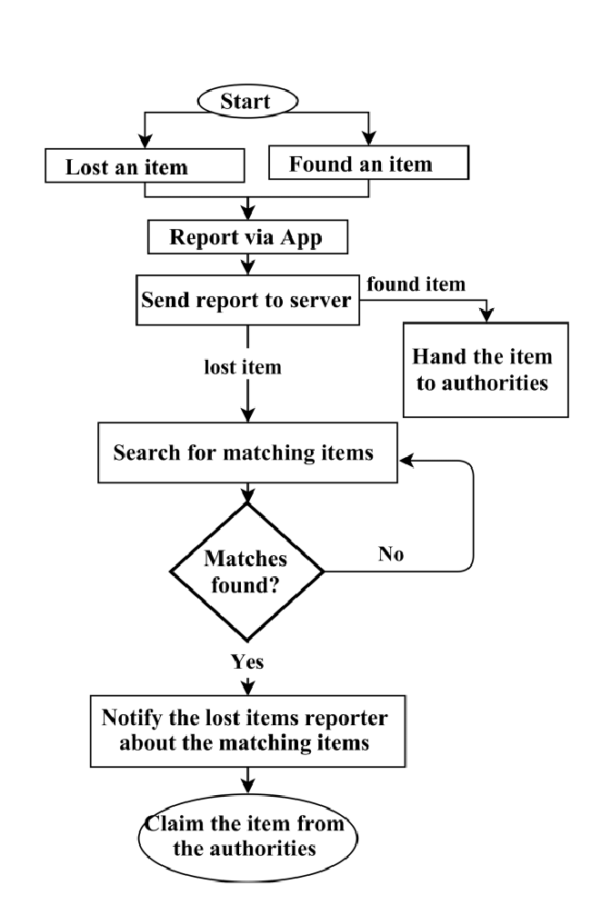

Figure 1

7.4 Data Flow Diagram:
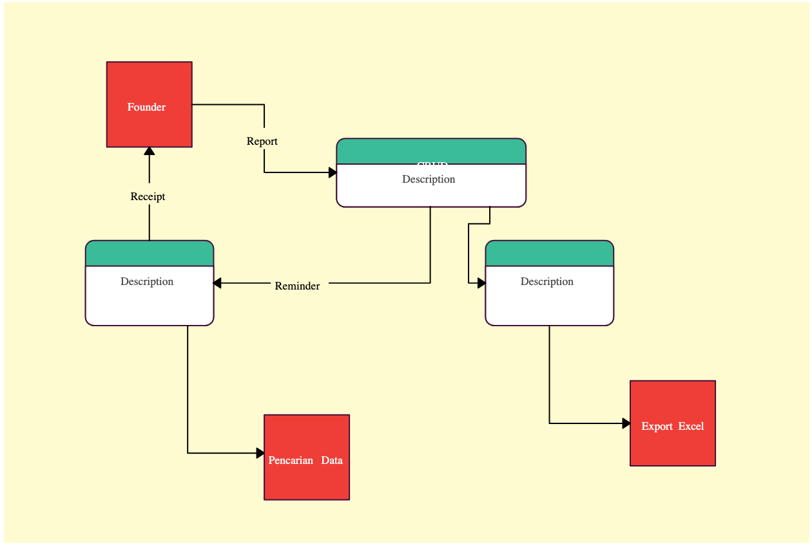
Creating a Data Flow Diagram (DFD) involves illustrating the flow of data within a system, highlighting processes, data stores, data sources, and data destinations. Here's a textual representation of a simple DFD for the "Lost and Found System":

7.5 Use Case Diagram:
A Use Case Diagram represents the interactions between the system and its users (actors). It illustrates the various use cases (functional requirements) of the system and how actors interact with the system to achieve specific goals.

7.5.1 Use Case for Admin
The Use Case for Admin describes the interactions and functionalities specific to the system administrator. It illustrates the actions that the admin can perform, such as managing user accounts, generating reports, or configuring system settings.

7.5.2 Use Case for User
Use Case: Report Lost Item
In this scenario, a registered user logs into the system and reports a lost item by providing details such as description, category, and location. The system validates and stores the information, confirming the successful report to the user. If issues arise, error messages guide the user through corrections. Unauthorized attempts prompt users to log in or register.
Use Case: Search for Found Items
A logged-in user searches for found items using filters like category and location. The system retrieves matching items, displaying detailed information. If no results are found, the system notifies the user to adjust search criteria. Unregistered users are prompted to log in or register before searching.
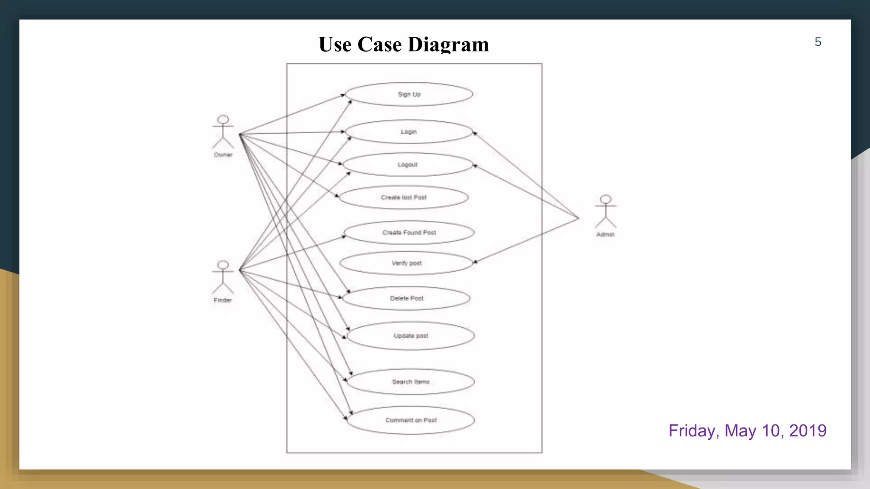

7.6 Activity Diagram
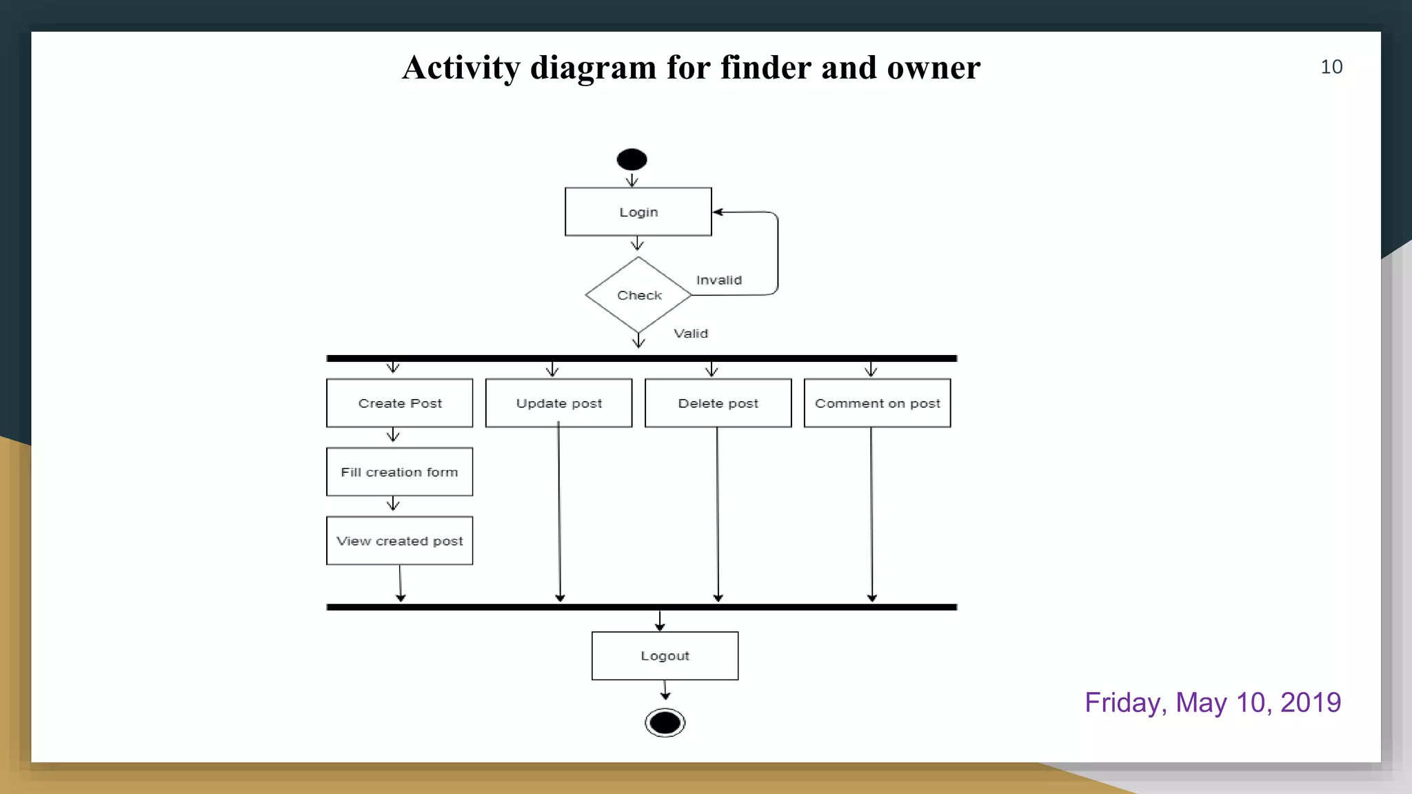
An Activity Diagram illustrates the flow of activities or processes within the system. It represents the sequence of actions and decision points, providing a visual representation of the system's behavior.

7.7 Sequence Diagram
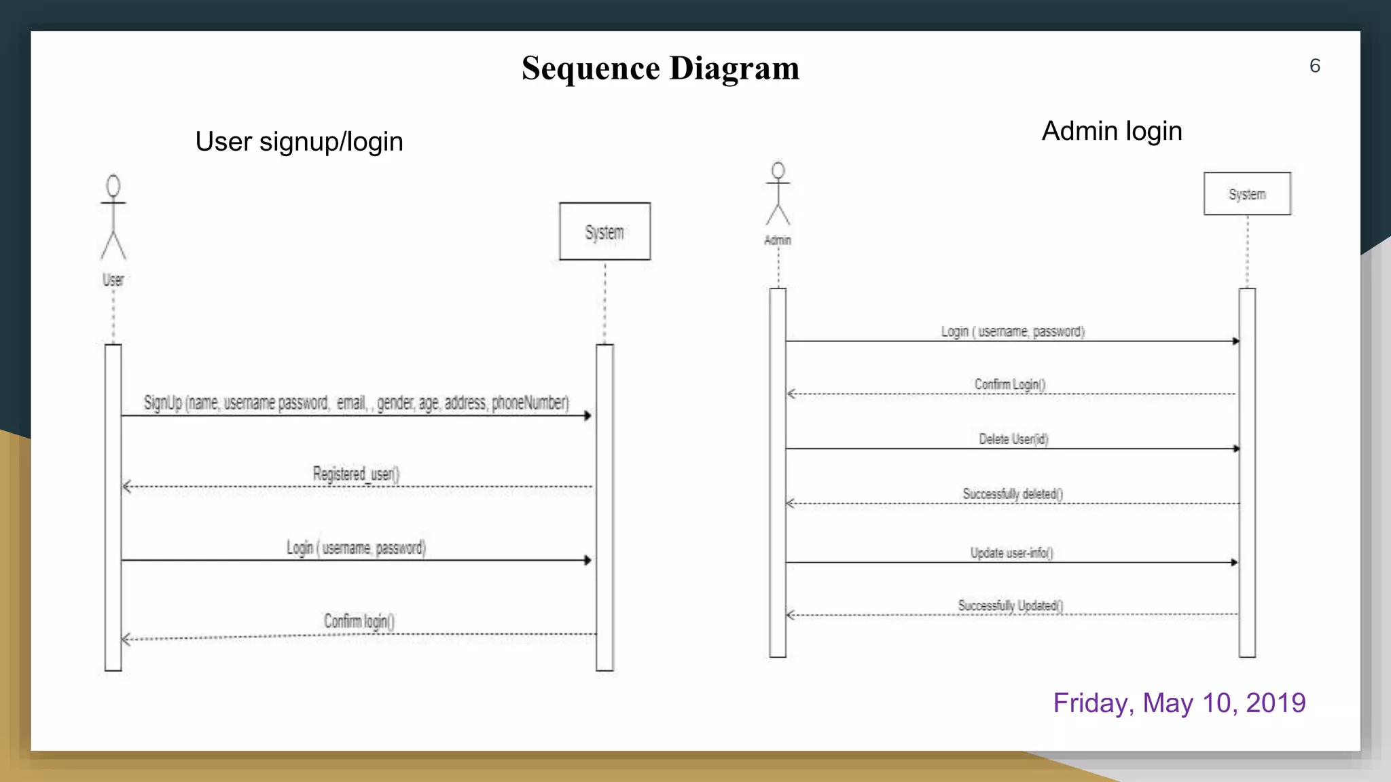
A Sequence Diagram shows the interaction between different objects or components within the system over time. It illustrates the chronological order of messages exchanged between objects, helping to visualize the system's dynamic behavior.

7.8 Class Diagram
A Class Diagram represents the system's static structure, depicting the classes, attributes, methods, and relationships between objects. It provides a high-level view of the system's object-oriented design.
.
CHAPTER 8:
IMPLEMENTATION

Code:
Dashboard.php
<!DOCTYPE html>
<html lang="en">

<head>
<meta charset="utf-8">
<meta name="viewport" content="width=device-width, initial-scale=1">
<title>Mandsaur university Lost and Found System</title>

<!-- Google Font: Source Sans Pro -->
<link rel="stylesheet" href="https://fonts.googleapis.com/css?family=Source+Sans+Pro:300,400,400i,700&display=fallback">
<!-- Font Awesome -->
<link rel="stylesheet" href="plugins/fontawesome-free/css/all.min.css">
<!-- Ionicons -->
<link rel="stylesheet" href="https://code.ionicframework.com/ionicons/2.0.1/css/ionicons.min.css">
<!-- Tempusdominus Bootstrap 4 -->
<link rel="stylesheet" href="plugins/tempusdominus-bootstrap-4/css/tempusdominus-bootstrap-4.min.css">
<!-- iCheck -->
<link rel="stylesheet" href="plugins/icheck-bootstrap/icheck-bootstrap.min.css">
<!-- JQVMap -->
<link rel="stylesheet" href="plugins/jqvmap/jqvmap.min.css">
<!-- Theme style -->
<link rel="stylesheet" href="dist/css/adminlte.min.css">
<!-- overlayScrollbars -->
<link rel="stylesheet" href="plugins/overlayScrollbars/css/OverlayScrollbars.min.css">
<!-- Daterange picker -->
<link rel="stylesheet" href="plugins/daterangepicker/daterangepicker.css">
<!-- summernote -->
<link rel="stylesheet" href="plugins/summernote/summernote-bs4.min.css">
</head>
<body class="hold-transition sidebar-mini layout-fixed">
<div class="wrapper">

<!-- Navbar -->
<nav class="main-header navbar navbar-expand navbar-white navbar-light">
<!-- Left navbar links -->
<ul class="navbar-nav">
<li class="nav-item">
<a class="nav-link" data-widget="pushmenu" href="#" role="button"><i class="fas fa-bars"></i></a>
</li>

</ul>

<!-- Right navbar links -->
<ul class="navbar-nav ml-auto">
<!-- Messages Dropdown Menu -->

<!-- Notifications Dropdown Menu -->
<!-- to full screen program -->
<li class="nav-item">
<a class="nav-link" data-widget="fullscreen" href="#" role="button">
<i class="fas fa-expand-arrows-alt"></i>
</a>
</li>

</ul>
</nav>
<!-- /.navbar -->

<!-- Main Sidebar Container -->
<aside class="main-sidebar sidebar-dark-primary elevation-4">
<!-- Brand Logo -->
<a href="" class="brand-link">
<img src="dist/img/mandsaur university.jpg" alt="AdminLTE Logo" class="brand-image img-circle elevation-3" style="opacity: .8">
<span class="brand-text font-weight-light">Mandsaur university</br>Lost and Found</span>
</a>

<!-- Sidebar -->
<div class="sidebar">
<!-- Sidebar user panel (optional) -->
<div class="user-panel mt-3 pb-3 mb-3 d-flex">
<div class="image">
<img src="dist/img/avatar.png" class="img-square elevation-3" style="width:30px; border-radius:10%;" alt="User Image"> </div>
<div class="info">
<a href="#" class="d-block" style="margin-top: -12px"><?php session_start(); echo $_SESSION["username"]; ?></a>

<!-- <a href="#" class="d-block" style="margin-top: -12px"><$loggedInUsername</a> -->
<a href="#" style="color: #239db1; font-size: 15px"><i class="fa fa-circle text-primary" style="font-size: 13px;"></i> Admin</a>
</div>

</div>

<!-- Sidebar Menu -->
<nav class="mt-2">
<ul class="nav nav-pills nav-sidebar flex-column" data-widget="treeview" role="menu" data-accordion="false">
<!-- Add icons to the links using the .nav-icon class
with font-awesome or any other icon font library -->
<li class="nav-item menu-open">

<a href="dashboard.php" class="nav-link active">
<i class="nav-icon fas fa-tachometer-alt"></i>
<p>
Dashboard
</p>
</a>
</li>
<li class="nav-item">
<a href="lostandfound.php" class="nav-link">
<i class="nav-icon fas fa-list-alt"></i>
<p>
Lost and Found Item
</p>
</a>
</li>
<li class="nav-item">
<a href="postimages.php" class="nav-link">
<i class="nav-icon fas fa-edit"></i>
<p>
Post Images
</p>
</a>
</li>
<li class="nav-item">
<a href="postcategory.php" class="nav-link">
<i class="nav-icon fas fa-list"></i>
<p>
Post Category
</p>
</a>
</li>
<li class="nav-item">
<a href="memberinfo.php" class="nav-link">
<i class="nav-icon fas fa-info-circle"></i>
<p>
Member Information
</p>
</a>
</li>
<li class="nav-item">
<a href="membercredential.php" class="nav-link">
<i class="nav-icon fas fa-id-card"></i>
<p>
Member Credential
</p>
</a>
</li>
<li class="nav-item">
<a href="usermanagement.php" class="nav-link">
<i class="nav-icon fas fa-users-cog"></i>
<p>
User Management
</p>
</a>
</li>
<li class="nav-item">
<a href="usergroup.php" class="nav-link">
<i class="nav-icon fas fa-users"></i>
<p>
User Group
</p>
</a>
</li>
<li class="nav-item">
<a href="usergroup.php" class="nav-link">
<i class="nav-icon fas fa-users"></i>
<p>
REPORT
</p>
</a>
</li>

<li class="nav-item">
<a href="../index.php" class="nav-link">
<i class="nav-icon fas fa-power-off"></i>
<p>
Logout
</p>
</a>
</li>

</ul>
</nav>
<!-- /.sidebar-menu -->
</div>
<!-- /.sidebar -->
</aside>

<!-- Content Wrapper. Contains page content -->
<div class="content-wrapper">
<!-- Content Header (Page header) -->
<div class="content-header">
<div class="container-fluid">
<div class="row mb-2">
<div class="col-sm-6">
<h1 class="m-0">Dashboard</h1>
</div><!-- /.col -->
<div class="col-sm-6">
<ol class="breadcrumb float-sm-right">
<li class="breadcrumb-item"><a href="#">Home</a></li>
<li class="breadcrumb-item active">Dashboard</li>
</ol>
</div><!-- /.col -->
</div><!-- /.row -->
</div><!-- /.container-fluid -->
</div>
<!-- /.content-header -->

<!-- Main content -->
<section class="content">
<div class="container-fluid">
<!-- Small boxes (Stat box) -->
<div class="row">
<div class="col-lg-4 col-6">
<!-- small box -->
<div class="small-box bg-info">
<div class="inner">
<!-- Now, you can use $totalUsers in your HTML -->
<h3>Total Users:</h3>
<p>Total Members</p>
</div>
<div class="icon">
<i class="fa fa-users"></i>
</div>
<a href="usermanagement.php" class="small-box-footer">More info <i class="fas fa-arrow-circle-right"></i></a>
</div>
</div>
<div class="col-lg-4 col-6">
<!-- small box -->
<!-- <div>//class i know to know -->
<div class="small-box bg-primary">
<div class="inner">
<h3>150</h3>

<p>Total Lost Items</p>
</div>
<div class="icon">
<i class="fa fa-briefcase"></i>
</div>
<a href="usermanagement.php" class="small-box-footer">More info <i class="fas fa-arrow-circle-right"></i></a>
</div>
</div>
<!-- ./col -->
<div class="col-lg-4 col-6">
<!-- small box -->
<div class="small-box bg-success">
<div class="inner">
<h3>53<sup style="font-size: 20px"></sup></h3>

<p>Total Found Items</p>
</div>
<div class="icon">
<i class="fa fa-briefcase"></i>
</div>
<a href="#" class="small-box-footer">More info <i class="fas fa-arrow-circle-right"></i></a>
</div>
</div>

</div>
<!-- /.row -->
<!-- Main row -->
<div class="row">

</div>
<!-- /.row (main row) -->
</div><!-- /.container-fluid -->
</section>
<!-- /.content -->
</div>
<!-- /.content-wrapper -->
<footer class="main-footer">
<strong>Footer <a href="">Lost and Found System</a>.</strong>
All rights reserved.
<div class="float-right d-none d-sm-inline-block">
<b>Footer</b>
</div>
</footer>

<!-- Control Sidebar -->
<aside class="control-sidebar control-sidebar-dark">
<!-- Control sidebar content goes here -->
</aside>
<!-- /.control-sidebar -->
</div>
<!-- ./wrapper -->

<!-- jQuery -->
<script src="plugins/jquery/jquery.min.js"></script>
<!-- jQuery UI 1.11.4 -->
<script src="plugins/jquery-ui/jquery-ui.min.js"></script>
<!-- Resolve conflict in jQuery UI tooltip with Bootstrap tooltip -->
<script>
$.widget.bridge('uibutton', $.ui.button)
</script>
<!-- Bootstrap 4 -->
<script src="plugins/bootstrap/js/bootstrap.bundle.min.js"></script>
<!-- ChartJS -->
<script src="plugins/chart.js/Chart.min.js"></script>
<!-- Sparkline -->
<script src="plugins/sparklines/sparkline.js"></script>
<!-- JQVMap -->
<script src="plugins/jqvmap/jquery.vmap.min.js"></script>
<script src="plugins/jqvmap/maps/jquery.vmap.usa.js"></script>
<!-- jQuery Knob Chart -->
<script src="plugins/jquery-knob/jquery.knob.min.js"></script>
<!-- daterangepicker -->
<script src="plugins/moment/moment.min.js"></script>
<script src="plugins/daterangepicker/daterangepicker.js"></script>
<!-- Tempusdominus Bootstrap 4 -->
<script src="plugins/tempusdominus-bootstrap-4/js/tempusdominus-bootstrap-4.min.js"></script>
<!-- Summernote -->
<script src="plugins/summernote/summernote-bs4.min.js"></script>
<!-- overlayScrollbars -->
<script src="plugins/overlayScrollbars/js/jquery.overlayScrollbars.min.js"></script>
<!-- AdminLTE App —>
<script src="dist/js/adminlte.js"></script>
<!-- AdminLTE for demo purposes -->
<script src="dist/js/demo.js"></script>
<!-- AdminLTE dashboard demo (This is only for demo purposes) -->
<script src="dist/js/pages/dashboard.js"></script>
</body>
</html>

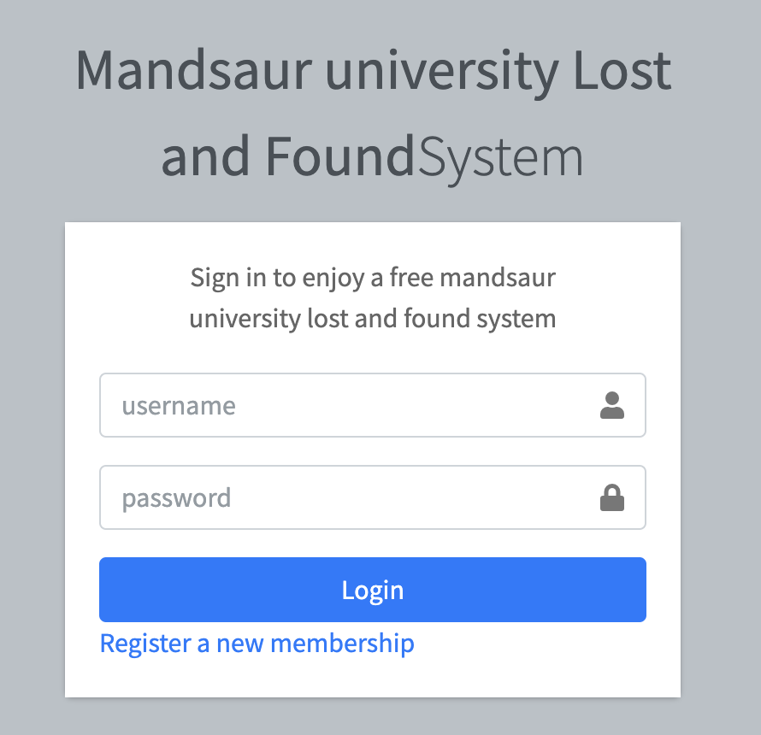
Login interface :

Admin interface :
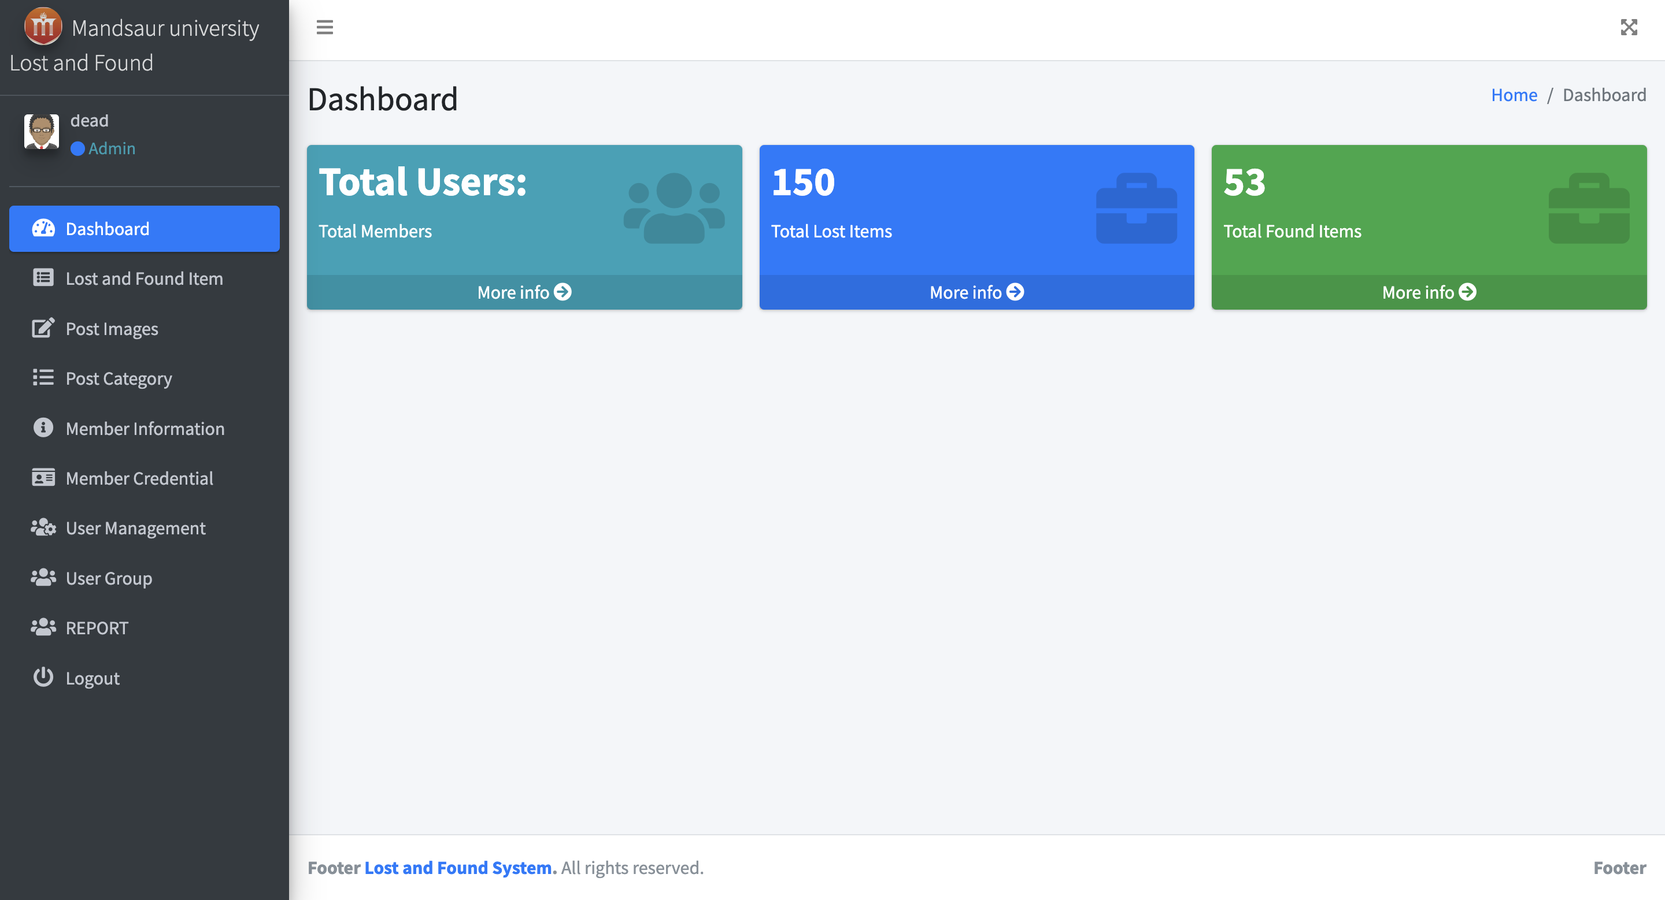

User interface
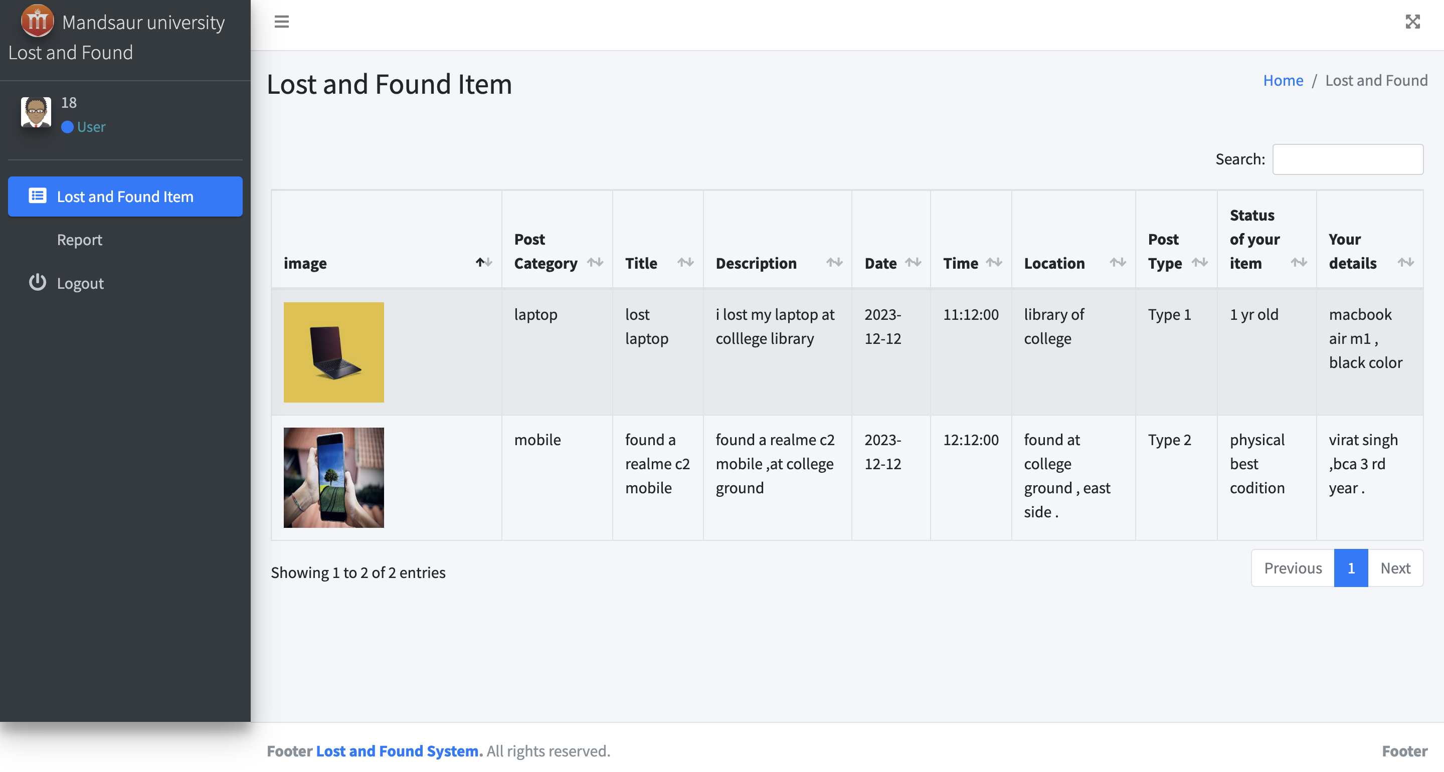

CHAPTER 9:
TESTING

9.1 Unit Testing
Unit testing in the "Lost and Found System" involves testing individual components of code in isolation to ensure their correct functionality. Each function or method is examined with various input scenarios, and automated tests are integrated into the development process to detect and correct bugs early on. Unit testing provides early bug detection, supports code refactoring, enhances overall code quality, and serves as executable documentation for the system's components. This practice contributes to a more reliable and maintainable software development process.

9.2 Integration Testing
Integration testing in the "Lost and Found System" is the process of evaluating the interaction between different components to ensure they work seamlessly together. This testing phase assesses the interfaces, data flow, and communication between interconnected modules, verifying that integrated parts of the system function as expected. Integration tests help identify and rectify issues arising from the collaboration of components, ensuring the overall system operates cohesively. This testing stage is crucial for detecting interface mismatches, data flow irregularities, and dependencies between modules, promoting a robust and well-coordinated system.

9.3 Validation Testing
Validation testing in the "Lost and Found System" is the phase where the entire system is evaluated to ensure it meets specified requirements and satisfies user needs. This testing assesses the overall functionality, performance, and behavior of the system in a real-world context. Validation tests validate that the system accomplishes its intended purpose, conforms to user expectations, and successfully addresses the identified use cases. Through comprehensive testing scenarios, validation testing guarantees that the "Lost and Found System" is ready for deployment, providing assurance that it aligns with user requirements and performs effectively in diverse scenarios.

9.4 Test Case Design
Test case design in the "Lost and Found System" involves creating detailed scenarios and conditions to systematically evaluate the functionality and performance of the system. This process includes defining input values, expected outcomes, and execution procedures for each test case. Test cases cover a range of scenarios, including typical use cases, boundary conditions, and exceptional situations to ensure comprehensive coverage. Well-designed test cases contribute to thorough testing, helping identify and rectify potential issues, and provide a structured approach to validating the system's functionality during unit, integration, and validation testing phases.

9.5 Test Cases
Test cases for the "Lost and Found System" are meticulously designed scenarios to validate the system's functionality across various stages of development. These cases cover a spectrum of scenarios, including reporting lost or found items, searching for items, and user authentication processes. Test cases specify input values, expected outcomes, and steps to execute the tests, ensuring comprehensive coverage. Examples include verifying successful item reporting, handling incorrect login credentials, and testing search functionalities with diverse criteria. These thoughtfully crafted test cases are essential for systematically assessing and assuring the reliability and correctness of the system's features.

CHAPTER 10:
COST ESTIMATION AND VERIFICATION CRITERIA

Cost Estimation:
Cost estimation is the process of predicting the resources required, both in terms of time and budget, for the successful completion of a project. Various methods can be used for cost estimation, including expert judgment, analogous estimation, parametric modeling, and three-point estimation. Here's a brief overview of some common estimation techniques:
Analogous Estimation: This method relies on historical data from similar projects to estimate the cost of the current project.
Parametric Modeling: This involves using statistical relationships between historical data and project parameters to estimate costs.
Three-Point Estimation: Based on optimistic, pessimistic, and most likely scenarios, this technique calculates the expected cost using a weighted average.
Expert Judgment: Involves seeking input from subject matter experts or industry specialists to estimate costs based on their experience and knowledge.
Verification Criteria:
Verification in the context of project management refers to the process of evaluating whether the work products of a particular phase meet the specified requirements. Verification criteria are the standards or benchmarks used to assess whether the deliverables or outcomes of a project meet the predefined quality standards. Here are some verification criteria examples:
Adherence to Requirements: Verify that the project deliverables meet the specified requirements outlined in the project documentation.
Compliance with Standards: Ensure that the project work follows industry or organizational standards relevant to the specific domain.
Accuracy: Verify the accuracy of data, calculations, and information used in the project work.
Completeness: Confirm that all necessary components and features have been implemented or included in the project deliverables.
Consistency: Ensure consistency across different parts of the project, avoiding conflicts or discrepancies.
Traceability: Establish traceability between project requirements, design documents, and implemented features to ensure alignment.
Performance: Verify that the project work meets performance expectations and criteria specified in the project plan.
Effective cost estimation and verification criteria contribute to successful project management by ensuring that projects are completed within budget, on schedule, and with the required level of quality and adherence to specifications.

CHAPTER 11:
LIMITATIONS OF PROJECT
The limitations of a project can arise from various factors and aspects of the project management process. Here are some common limitations that projects may encounter:
- Scope Creep: As the project progresses, there is a tendency for the scope to expand beyond the originally defined boundaries. Additional requirements or changes may be introduced, leading to increased complexity and potential delays.
- Resource Constraints: Projects often face limitations in terms of budget, time, and available human resources. Inadequate resources can hinder the completion of tasks and may require compromises on project goals.
- Uncertain Requirements: Unclear or evolving project requirements can pose a significant challenge. Changes in client needs or market conditions may impact the project, leading to adjustments in scope and objectives.
- Technology Constraints: Dependence on specific technologies or tools can become a limitation if these technologies become outdated or if the project requires expertise that is not readily available.
- Risks and Uncertainties: Project environments are inherently uncertain, and unforeseen risks can impact the project's progress. Lack of proper risk management may result in unanticipated issues and disruptions.
- Communication Challenges: Ineffective communication among team members, stakeholders, or between different project phases can lead to misunderstandings, delays, and project deviations.
- Stakeholder Conflicts: Conflicts among project stakeholders, including team members, clients, and sponsors, can negatively impact decision-making and project progress.
- Quality Assurance Challenges: Ensuring that project deliverables meet quality standards can be challenging. Inadequate testing and quality assurance processes may lead to defects and rework.
- Dependencies on External Factors: Projects often depend on external factors such as government regulations, market conditions, or the availability of third-party services. Changes in these external factors can pose limitations.
- Limited Flexibility: Projects that lack adaptability and flexibility may struggle to accommodate changes in requirements, technology, or market conditions.
- Inadequate Project Management: Weak project management practices, including poor planning, monitoring, and control, can lead to project limitations. This includes issues related to timelines, budget overruns, and overall project performance.
Recognizing these limitations early in the project life cycle and implementing effective project management strategies, including risk management, stakeholder engagement, and continuous improvement, can help mitigate these challenges and enhance the chances of project success. Regular monitoring and adaptation to changing circumstances are essential for addressing limitations as they arise.

CHAPTER 12:
FUTURE SCOPE

The future scope of a project refers to potential advancements, expansions, or applications beyond its current state. For the "Lost and Found System," several avenues for future development and enhancement can be considered:
- Enhanced Features: Continuous improvement of features based on user feedback and technological advancements. This may include refining the user interface, introducing new search algorithms, or incorporating additional categories for items.
- Mobile Application: Developing a mobile application for the lost and found system can broaden its accessibility, allowing users to report or search for lost items conveniently from their smartphones.
- Geolocation Integration: Implementing geolocation features to enhance the accuracy of reporting and searching for lost items based on their last known locations.
- Integration with Social Media: Allowing users to share lost and found information on social media platforms can increase the reach and effectiveness of the system, leveraging the power of social networks.
- Machine Learning for Matching: Implementing machine learning algorithms to improve the accuracy of matching lost and found items. This could involve pattern recognition and more sophisticated matching criteria.
- Integration with Law Enforcement: Collaborating with law enforcement agencies to facilitate the recovery of lost items that might be of interest in ongoing investigations.
- User Accounts and Profiles: Developing user accounts with profiles and histories can enhance the user experience. Users may have a dashboard to manage their reported and found items, track their interactions, and receive personalized recommendations.
- Crowdsourcing and Community Involvement: Encouraging community participation and crowdsourcing for lost and found information can create a more extensive network of users and increase the system's effectiveness.
- Data Analytics: Implementing data analytics to gain insights into lost and found patterns, user behaviors, and system performance. This can aid in making informed decisions for future enhancements.
- Blockchain Integration: Exploring blockchain technology for secure and transparent recording of lost and found transactions, ensuring the integrity and traceability of the data.
- Internationalization: Expanding the system's reach by providing multilingual support and adapting it to international lost and found standards.
- Accessibility Features: Improving the system's accessibility features to cater to users with disabilities, ensuring inclusivity.
These future scope considerations depend on technological advancements, user needs, and market trends. Regularly assessing these factors and staying abreast of emerging technologies can guide the evolution of the "Lost and Found System" to meet changing demands and remain relevant in the long term.

CHAPTER 13:
CONCLUSION

In conclusion, the "Lost and Found System" presents a valuable solution for addressing the challenges associated with retrieving lost items in a user-friendly and efficient manner. The project aims to streamline the process of reporting and searching for lost items, enhancing user experience and community engagement.

Through the project's life cycle, various phases such as planning, design, and testing have been meticulously executed to ensure the system's reliability, security, and effectiveness. The implementation of unit testing, integration testing, and validation testing has contributed to the robustness of the system, mitigating potential issues and delivering a high-quality solution.

The limitations inherent in any project, including scope creep, resource constraints, and evolving requirements, have been acknowledged. These challenges have been addressed through effective project management strategies, emphasizing adaptability, clear communication, and proactive risk management.

Looking ahead, the future scope of the "Lost and Found System" holds exciting possibilities for improvement and expansion. Incorporating features such as mobile applications, geolocation integration, and machine learning for matching can elevate the system's capabilities and user engagement. Collaboration with law enforcement, social media integration, and community involvement can further enhance the system's impact on a broader scale.

In essence, the "Lost and Found System" serves as a foundation for a community-driven solution to the common issue of lost items. The project's success lies not only in its current functionality but in its potential for growth and adaptation to meet evolving user needs and technological advancements. As the system evolves, it is poised to make a meaningful contribution to facilitating the recovery of lost items, fostering community collaboration, and improving overall user satisfaction.

CHAPTER 14:
BIBLIOGRAPHY/REFERENCES

Lost and Found System. Mandsaur university personal system for students.

